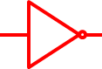

F

F

T

T

F

F

F

T

T

T

T

T

F

F

T

F